### Remove Seasonality

d = na.omit(d)  
pd3 = xts(d$driving, as.Date(d$Dates, format = '%Y-%m-%d'))

## method 1, use diff()

# first-differencing a time series at a lag equal to the period will remove a seasonal trend   
#Reference: https://nwfsc-timeseries.github.io/atsa-labs/sec-tslab-differencing-to-remove-a-trend-or-seasonal-effects.html  
diff(pd3, differences = 1, lag = 366)

## Error in lag.xts(x, k = lag, na.pad = na.pad): abs(k) must be less than nrow(x)

#insufficient daily data

## method 2, use decompose() & diff()

decomd = decompose(pd3)

## Error in decompose(pd3): time series has no or less than 2 periods

pd3adj = pd3 - decomd$seasonal #removing seasonality

## Error in eval(expr, envir, enclos): object 'decomd' not found

n = ndiffs(pd3adj)

## Error in na.omit(c(x)): object 'pd3adj' not found

pd4 = diff(pd3adj, differences = n) #making the data stationary

## Error in diff(pd3adj, differences = n): object 'pd3adj' not found

p3 = autoplot(pd4) + scale_x_date(date_labels = "%B-%Y")

## Error in autoplot(pd4): object 'pd4' not found

## method 3, use stl()

decompose(pd3)

## Error in decompose(pd3): time series has no or less than 2 periods

stl(pd3)

## Error in stl(pd3): series is not periodic or has less than two periods

# has insufficient periods

## method 4, use SMA() to smooth time series data

ma1 = SMA(pd3, n = 7)   
p5 = autoplot(ma1) + xlab("") + ylab("% Change in Mobility") + ggtitle("Adjusted %Change in Driving Mobility of State Colorado")  
  
ma2 = SMA(pd3, n = 30)   
p6 = autoplot(ma2) + xlab("") + ylab("% Change in Mobility") + ggtitle("Adjusted %Change in Driving Mobility of State Colorado")

#Reference: https://a-little-book-of-r-for-time-series.readthedocs.io/en/latest/src/timeseries.html  
#https://bookdown.org/kochiuyu/technical-analysis-with-r-second-edition/simple-moving-average-sma.html#ttr

## 

**(Number of periods to average over = 7)**

## 

**(Number of periods to average over = 30)**

## method 5, using tslm()

dd.s = diff(pd3, lag = 366)

## Error in lag.xts(x, k = lag, na.pad = na.pad): abs(k) must be less than nrow(x)

# Deseasonalize the data  
dd.m = tslm(dd.s ~ season)

## Error in (function (..., flatten = TRUE, functions = TRUE) : object 'dd.s' not found

dd.ts = residuals(dd.m)

## Error in residuals(dd.m): object 'dd.m' not found

#insufficient daily data

## method 6, work on only weekly & monthly values

#get weekly values  
wkd = d %>%  
 filter(row_number() %% 7 == 1) %>%  
 na.omit()  
wkd1 = xts(wkd$driving, as.Date(wkd$Dates, format = '%Y-%m-%d'))  
wkd2 = d %>%  
 filter(row_number() %% 7 == 1) %>%  
 na.omit() %>%  
 ts(start = c(2020, 2), frequency = 52)  
#get monthly values (January to July)  
interval = c(1, 32, 61, 92, 120, 151, 181)  
mthd = d %>%   
 slice(interval) %>%  
 na.omit()  
mthd1 = xts(mthd$driving, as.Date(mthd$Dates, format = '%Y-%m-%d'))  
  
mthd2 = pd %>%   
 slice(interval) %>%  
 na.omit(mthd) %>%  
 ts(start = c(2020, 1), end = c(2020, 8), frequency = 12)

# using diff()

diff(wkd1, differences = 1, lag = 52)

## Error in lag.xts(x, k = lag, na.pad = na.pad): abs(k) must be less than nrow(x)

diff(mthd1, differences = 1, lag = 12)

## Error in lag.xts(x, k = lag, na.pad = na.pad): abs(k) must be less than nrow(x)

#insufficient weekly and monthly data

# using X11 decomposition for monthly data

f = seas(mthd2, x11 = "")

## Error in seas(mthd2, x11 = ""): could not find function "seas"

#insufficient annually data

# using ds() from deseasonalize package

ds(mthd2, type = c("monthly"), searchQ = TRUE)

## Error in ds(mthd2, type = c("monthly"), searchQ = TRUE): error: need at least one year (366 days or 12 months)

#need at least one year (366 days or 12 months)

# using tslm() & diff()

#Reference: http://people.brandeis.edu/~blebaron/classes/fin250a/regression/gdpSeasonal.html#some-r-experiments  
  
pd5 = diff(wkd2, lag = 52)  
pd6 = diff(mthd2, lag = 12)  
# Deseasonalize the data  
  
wkds = tslm(pd5 ~ season)

## Error in tslm(pd5 ~ season): Not time series data, use lm()

wkds.ts = residuals(wkds)

## Error in residuals(wkds): object 'wkds' not found

mths = tslm(pd6 ~ season)

## Error in tslm(pd6 ~ season): Not time series data, use lm()

mths.ts = residuals(mths)

## Error in residuals(mths): object 'mths' not found

#insufficient weekly and monthly data

# use tslm()

#weekly data  
wkd.mod2 = tslm(wkd2 ~ season)   
wkd.mean = mean(wkd2)  
wkd.sa = wkd.mod2$residuals + wkd.mean  
wkd.sa.ts = xts(as.vector(wkd.sa), as.Date(wkd$Dates, format = '%Y-%m-%d'))  
p7 = autoplot(wkd.sa.ts) + xlab("") + ylab("% Change in Mobility") + ggtitle("Adjusted %Change in Driving Mobility of State Colorado")

#This method doesn't work, since wkd.mod2$residuals = 0.

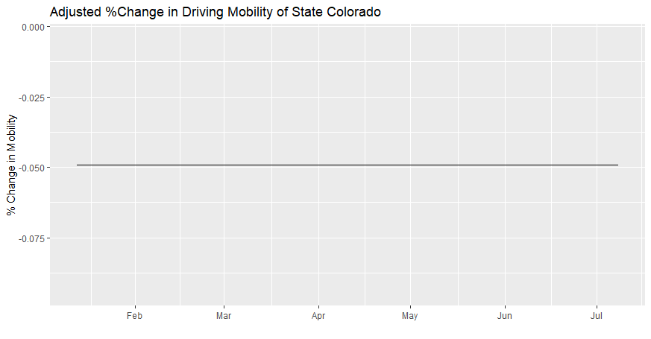

**(from weekly data)**

#monthly data  
mthd.mod2 = tslm(mthd2 ~ seasonaldummy(mthd2))  
mthd.mean = mean(mthd2)  
mthd.sa = mthd.mod2$residuals + mthd.mean  
mthd.sa.ts = xts(as.vector(mthd.sa), as.Date(c(mthd$Dates, "2020-08-13"), format = '%Y-%m-%d'))  
p8 = autoplot(mthd.sa.ts) + xlab("") + ylab("% Change in Mobility") + ggtitle("Adjusted %Change in Driving Mobility of State Colorado")

#This method doesn't work, since mthd.mod2$residuals = 0.

#Reference: <http://people.brandeis.edu/~blebaron/classes/fin250a/regression/trendSeason.html#logan-example-with-seasonals>

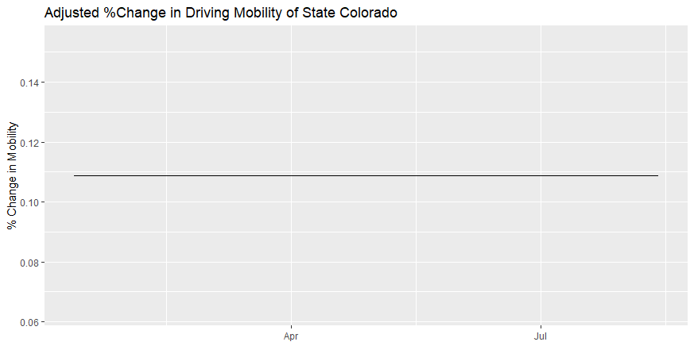

**(from monthly data)**